21BDS0340

Abhinav Dinesh Srivatsa

Course Code: BMAT101P

Class Number: VL2021220106766

# FAT Exam

## Problem 1

* Find the critical values of the function *f = 9x4 – 14x3 – 48x2 + 72x*
* Find the values of the second derivative of *f(x)* and check the sign of *f’’(x)* at the critical points
* Sketch the graph of the function *f(x)* with necessary title, axis, etc.

### Code:

syms x

% <----- a ----->

f(x) = 9*x^4 - 14*x^3 - 48*x^2 + 72*x;

I = [-5, 5];

interval = linspace(I(1), I(2), 10000);

F = double(f(interval));

[local_max, max_loc] = findpeaks(F);

[local_min, min_loc] = findpeaks(-F);

local_min = -local_min;

disp('(a). The critical values for maxima are:')

disp(local_max)

disp('(a). The critical values for minima are:')

disp(local_min)

% <----- b ----->

max_x_val = interval(max_loc);

min_x_val = interval(min_loc);

ddf = diff(diff(f));

double_der_val_max = double(ddf(max_x_val));

double_der_val_min = double(ddf(min_x_val));

disp('(b). The double derivitive value for maxima is:')

disp(double_der_val_max)

disp('(b). The double derivitive value for minima is:')

disp(double_der_val_min)

% <----- c ----->

figure

fplot(f);

xlabel('x');

ylabel('y');

legend('9x^4 - 14x^3 - 48x^2 + 72x');

title('Graph of function f(x)')

### Written Code:

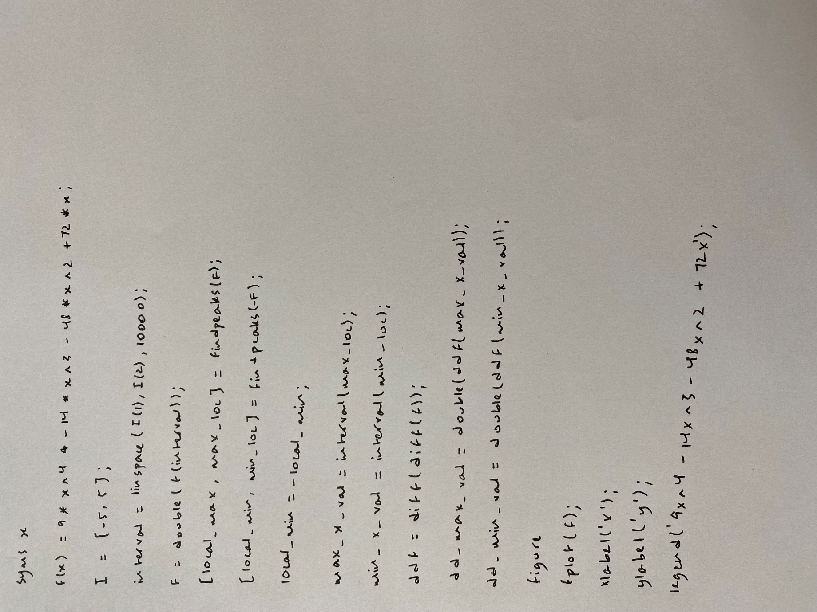

Output:

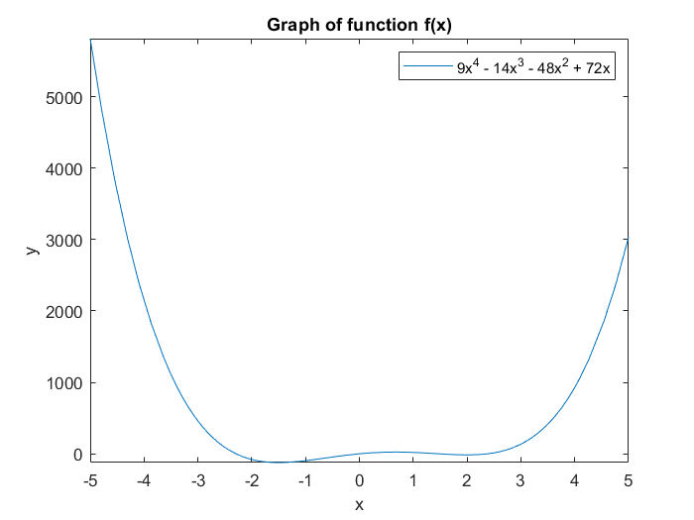

## Problem 2

* Find the gradient of the scalar function *f(x, y) = (x2 + y2)1/2*
* Plot the vector field of the gradient and show the scalar function using contour curves
* In the domain *-3π ≤ x ≤ 3π*, plot *y = sinx*. On the same graph, superimpose the curve *y = cosx* with a different colour. Indicate the x-label, y-label, title of the graph and legend

### Code:

syms x y

% <----- a ----->

f(x, y) = sqrt(x^2 + y^2);

xgrad(x, y) = diff(f, x);

ygrad(x, y) = diff(f, y);

grad = [xgrad, ygrad];

disp('(a). The gradient of the function is:')

disp(grad)

% <----- b ----->

figure

a = linspace(1, 5, 21);

[X, Y] = meshgrid(a, a);

U = xgrad(X, Y); V = ygrad(X, Y);

quiver(X, Y, U, V);

hold on

fcontour(f, [1 5])

xlabel('x')

ylabel('y')

legend('Quiver of gradient', 'Contour of function')

title('Quiver of gradient and Contours of function')

% <----- c ----->

figure

a = linspace(-3*pi, 3*pi, 10000);

f1(x) = sin(x); f2(x) = cos(x);

F1 = f1(a); F2 = f2(a);

plot(a, F1);

hold on

plot(a, F2);

xlabel('x')

ylabel('y')

legend('sin(x)', 'cos(x)')

title('Graph of sin(x) and cos(x)')

### Written Code:

Output:

